

“Transfiguration” Armando Alemdar Ara

The Last Sunday after the Epiphany
Transfiguration | Quinquagesima
1928 BCP Holy Communion

Sunday, February 15, 2026 + 10 AM
St. John’s Chapel Del Monte

Welcome to St. John’s Chapel!
We are glad that you are worshipping with us this morning and pray that your experience here is a blessing to you. If you are a visitor, please fill out a Connection Card (pew rack) and place it in the offering plate or hand it to an usher. Let this bulletin be your guide through the service; it includes everything you need.
We are at the end of the season of Epiphany. It all began Tuesday, January 6th, Epiphany Day, and will continue until this week on Ash Wednesday, February 18th. Epiphany Day’s theme was the manifestation, or showing forth, of Christ to the Gentiles with the arrival of the Magi at the manger. In the season of Epiphany, light is the primary symbol, with the Star of Bethlehem as the sign that Christ, the light of the world, has come.
Please stay for coffee in the Parish Hall after the service.
Throughout the service the People read the words in bold and italics.
PRELUDE
Standing as able
HYMN O wondrous type! H82 137

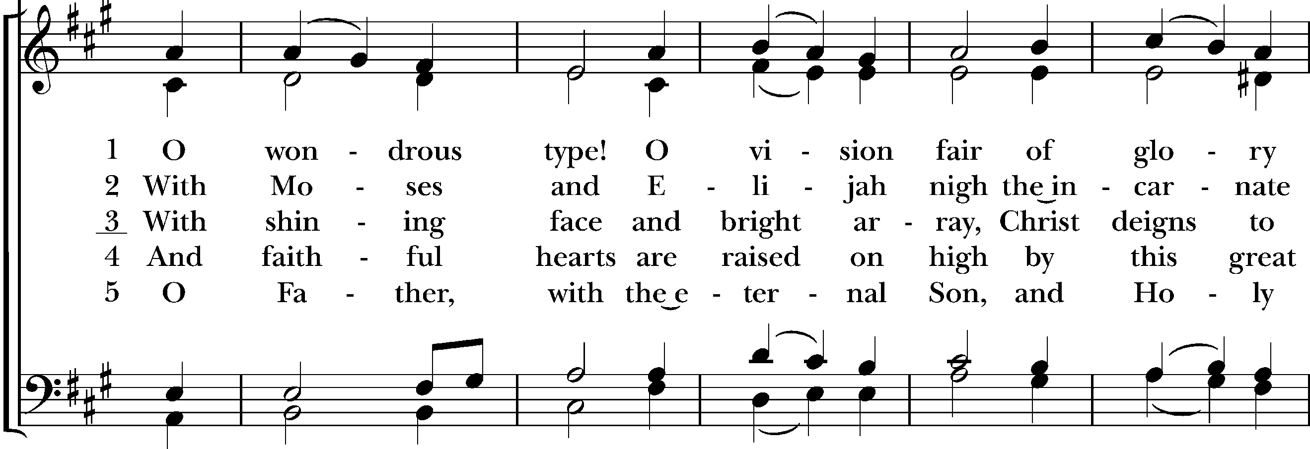

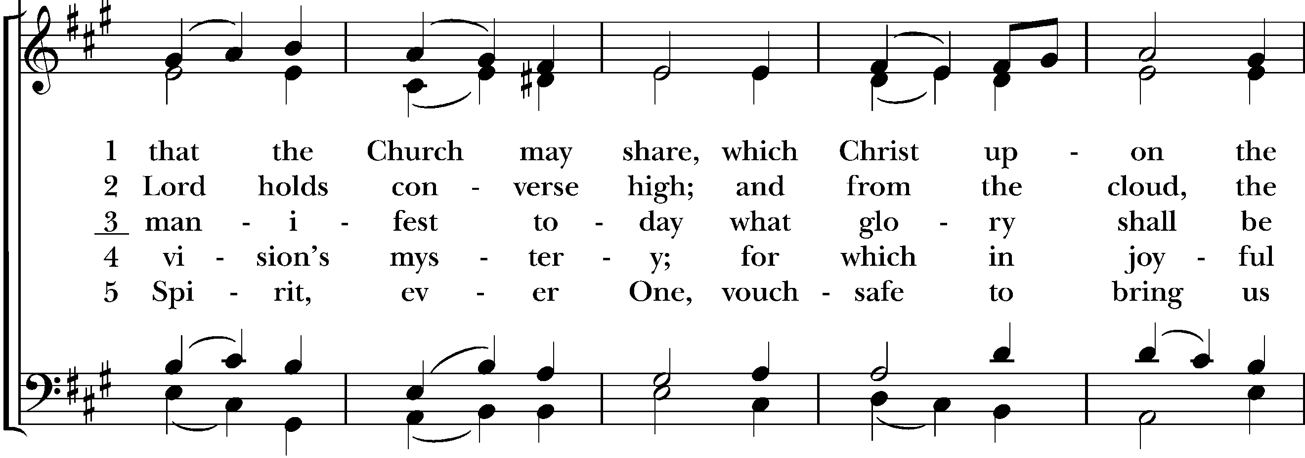

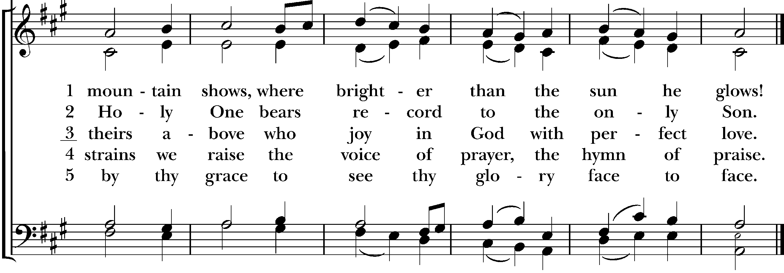

COLLECT FOR PURITY
And the Priest, standing reverently before the Holy Table, shall say the Collect following, the People kneeling
Almighty God, unto whom all hearts are open, all desires known, and from whom no secrets are hid; Cleanse the thoughts of our hearts by the inspiration of thy Holy Spirit, that we may perfectly love thee, and worthily magnify thy holy Name; through Christ our Lord. Amen.
THE SUMMARY OF THE LAW
Then shall the Priest, turning to the People, say
Hear what our Lord Jesus Christ saith.
Thou shalt love the Lord thy God with all thy heart, and with all thy soul, and with all thy mind. This is the first and great commandment. And the second is like unto it; Thou shalt love thy neighbour as thyself. On these two commandments hang all the Law and the Prophets.
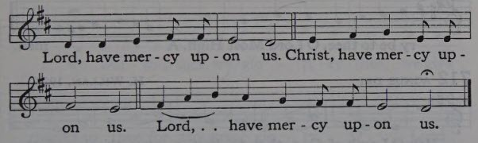
KYRIE

COLLECT OF THE DAY
The Priest says to the people
The Lord be with you.
People: And with thy spirit.
Priest: Let us pray.
The people kneeling as able
O God, who before the passion of your only begotten Son revealed his glory upon the holy mountain: Grant to us that we, beholding by faith the light of his countenance, may be strengthened to bear our cross, and be changed into his likeness from glory to glory; through Jesus Christ our Lord, who lives and reigns with you and the Holy Spirit, one God, for ever and ever. Amen.
The people sit
OLD TESTAMENT LESSON: Exodus 24:12-18
Reader: A reading from the 24th chapter of the Book of Exodus, beginning at the 12th verse.
And the Lord said unto Moses, Come up to me into the mount, and be there: and I will give thee tables of stone, and a law, and commandments which I have written; that thou mayest teach them. And Moses rose up, and his minister Joshua: and Moses went up into the mount of God. And he said unto the elders, Tarry ye here for us, until we come again unto you: and, behold, Aaron and Hur are with you: if any man have any matters to do, let him come unto them.
And Moses went up into the mount, and a cloud covered the mount. And the glory of the Lord abode upon mount Sinai, and the cloud covered it six days: and the seventh day he called unto Moses out of the midst of the cloud. And the sight of the glory of the Lord was like devouring fire on the top of the mount in the eyes of the children of Israel.
And Moses went into the midst of the cloud, and gat him up into the mount: and Moses was in the mount forty days and forty nights.
Reader: Here endeth the Old Testament Lesson.
Then shall follow a Portion of the Psalms. And at the end of the Psalm, shall be sung or said the Gloria Patri. Stand as able
PSALM 99 Dominus regnavit
Reader: We will read Psalm 99 responsively by the whole verse.
1 The Lord is King, be the people never so impatient; * he sitteth between the Cherubim, be the earth never so unquiet.
2 The Lord is great in Sion, * and high above all people.
3 They shall give thanks unto thy Name, * which is great, wonderful, and holy.
4 The King's power loveth judgment; thou hast prepared equity, * thou hast executed judgment and righteousness in Jacob.
5 O magnify the Lord our God, and fall down before his footstool; * for he is holy.
6 Moses and Aaron among his priests, and Samuel among such as call upon his Name: * these called upon the Lord, and he heard them.
7 He spake unto them out of the cloudy pillar; * for they kept his testimonies, and the law that he gave them.
8 Thou heardest them, O Lord our God; * thou forgavest them, O God, though thou didst punish their wicked doings.
9 O magnify the Lord our God, and worship him upon his holy hill; * for the LORD our God is holy.

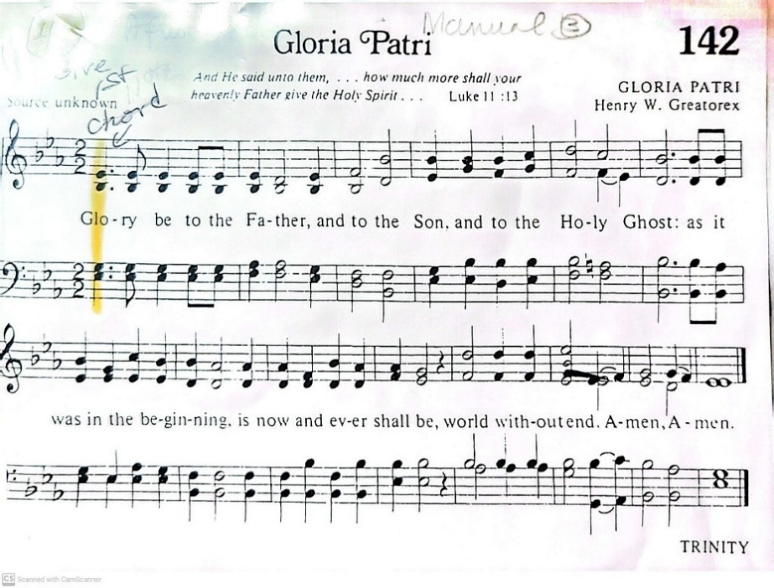

The people sit
THE EPISTLE: 2 Peter 1:16-21
Reader: A reading from the 1st chapter of the second Letter of Peter, beginning at the 16th verse.
For we have not followed cunningly devised fables, when we made known unto you the power and coming of our Lord Jesus Christ, but were eyewitnesses of his majesty. For he received from God the Father honour and glory, when there came such a voice to him from the excellent glory, This is my beloved Son, in whom I am well pleased.
And this voice which came from heaven we heard, when we were with him in the holy mount.
We have also a more sure word of prophecy; whereunto ye do well that ye take heed, as unto a light that shineth in a dark place, until the day dawn, and the day star arise in your hearts:
Knowing this first, that no prophecy of the scripture is of any private interpretation. For the prophecy came not in old time by the will of man: but holy men of God spake as they were moved by the Holy Ghost.
Reader: Here endeth the Epistle.
THE GOSPEL: St. Matthew 17:1-9
All standing as able
Priest The Holy Gospel is written in the 5th chapter of St. Matthew, beginning at the 13th verse.
GLORIA TIBI Glory be to thee, O Lord
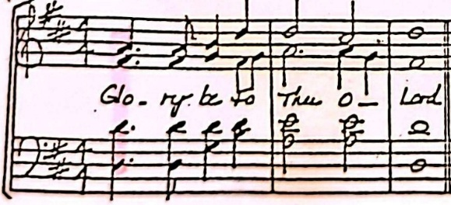

And after six days Jesus taketh Peter, James, and John his brother, and bringeth them up into an high mountain apart, And was transfigured before them: and his face did shine as the sun, and his raiment was white as the light. And, behold, there appeared unto them Moses and Elias talking with him. Then answered Peter, and said unto Jesus, Lord, it is good for us to be here: if thou wilt, let us make here three tabernacles; one for thee, and one for Moses, and one for Elias. While he yet spake, behold, a bright cloud overshadowed them: and behold a voice out of the cloud, which said, This is my beloved Son, in whom I am well pleased; hear ye him. And when the disciples heard it, they fell on their face, and were sore afraid. And Jesus came and touched them, and said, Arise, and be not afraid. And when they had lifted up their eyes, they saw no man, save Jesus only.
And as they came down from the mountain, Jesus charged them, saying, Tell the vision to no man, until the Son of man be risen again from the dead.
Priest The Gospel of the Lord.
LAUS TIBI Praise be to thee, O Christ
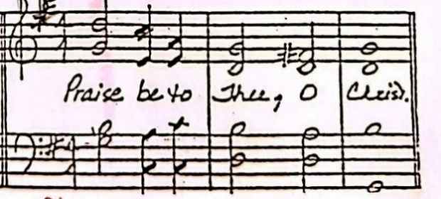

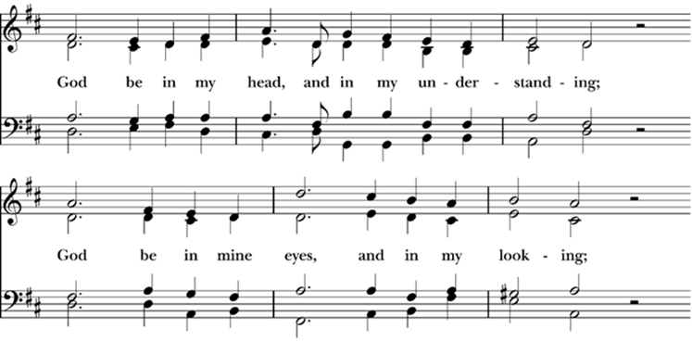
HYMN God be in my head H82 694

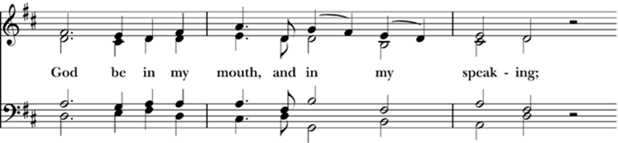

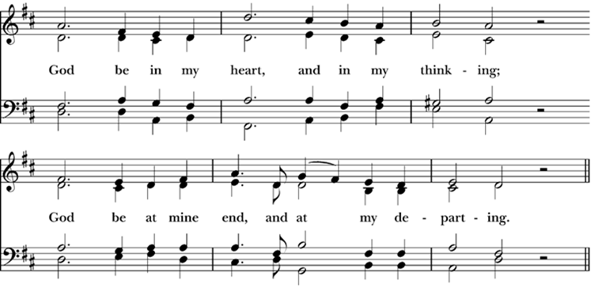

The people sit
SERMON Mountain High, Valley Low Fr. Rick Miles
All stand as able
THE NICENE CREED
I believe in one God the Father Almighty, Maker of heaven and earth, And of all things visible and invisible:
And in one Lord Jesus Christ, the only-begotten Son of God; Begotten of his Father before all worlds, God of God, Light of Light, Very God of very God; Begotten, not made; Being of one substance with the Father; By whom all things were made: Who for us men and for our salvation came down from heaven, And was incarnate by the Holy Ghost of the Virgin Mary, And was made man: And was crucified also for us under Pontius Pilate; He suffered and was buried: And the third day he rose again according to the Scriptures: And ascended into heaven, And sitteth on the right hand of the Father: And he shall come again, with glory, to judge both the quick and the dead; Whose kingdom shall have no end.
And I believe in the Holy Ghost, The Lord, and Giver of Life, Who proceedeth from the Father and the Son; Who with the Father and the Son together is worshipped and glorified; Who spake by the Prophets: And I believe one Catholic and Apostolic Church: I acknowledge one Baptism for the remission of sins: And I look for the Resurrection of the dead: And the Life of the world to come. Amen.
Please be seated
ANNOUNCEMENTS
BIRTHDAYS & ANNIVERSARIES
Birthday Prayer
Watch over your child/children, O Lord, as their days increase; bless and guide them wherever they may be. Strengthen them when they stand; comfort them when discouraged or sorrowful; raise them up if they fall; and in their heart may your peace which passes all understanding abide all the days of their life; through Jesus Christ our Lord. Amen.
Anniversary Prayer
God of peace, your love is generous and reaches out to hold us all in your embrace. We pray now for the couple(s) before us, committed to each other in love. Fill their hearts with tenderness. Stay with them as they travel through good times, through trouble, or through change. Bless their home, their partings, and their meetings. Make them worthy of each other’s best and tender with each other’s dreams. May they always trust in your love. Amen.

Prayer for Safe Travel
Living God, the creator of all there is and whose presence we find wherever we go: preserve those who travel; surround them with your loving care; guard them from all that may harm them: and bring them in safety and joy to their journey’s end. Amen.
OFFERTORY
Priest Let us with gladness present the offerings and oblations of our life and labour to the Lord.
HYMN 140 Praise to God, immortal praise
Sung while seated
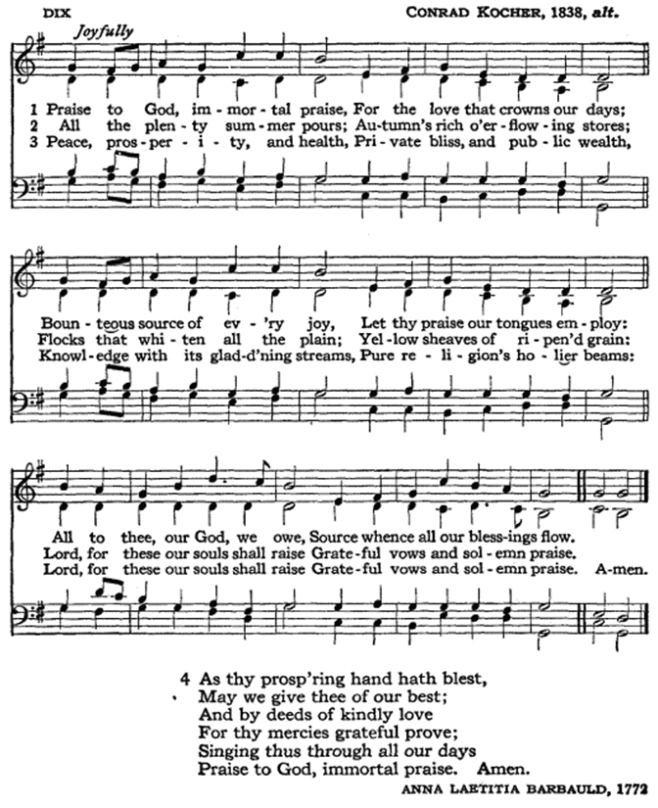

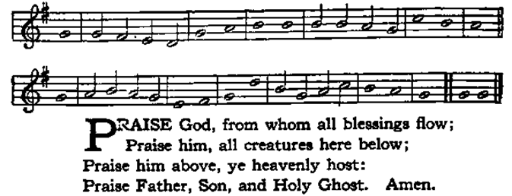
DOXOLOGY HYMN 139 Standing as able

AMERICA HYMN 141, v. 4
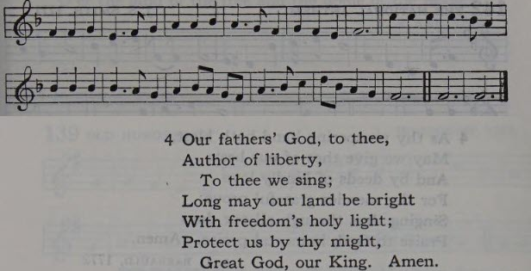

Standing as able
OFFERTORY PRAYER
Thine, O Lord, is the greatness, and the power, and the glory, and the victory, and the majesty: for all that is in the heaven and in the earth is thine; thine is the kingdom, O Lord, and thou art exalted as head above all.
Priest All things come of thee, O Lord,
People And of thine own have we given thee.
PRAYER FOR THE WHOLE STATE OF CHRIST’S CHURCH
People kneel and then shall the Priest, facing the altar, say
Let us pray for the whole state of Christ’s Church.
Almighty and everliving God, who by thy holy Apostle hast taught us to make prayers, and supplications, and to give thanks for all men; We humbly beseech thee most mercifully to accept our alms and oblations, and to receive these our prayers, which we offer unto thy Divine Majesty; beseeching thee to inspire continually the Universal Church with the spirit of truth, unity, and concord: And grant that all those who do confess thy holy Name may agree in the truth of thy holy Word, and live in unity and godly love. We beseech thee also, so to direct and dispose the hearts of all Christian Rulers, that they may truly and impartially administer justice, to the punishment of wickedness and vice, and to the maintenance of thy true religion, and virtue. Give grace, O heavenly Father, to all Bishops and other Ministers, that they may, both by their life and doctrine, set forth thy true and lively Word, and rightly and duly administer thy holy Sacraments. And to all thy People give thy heavenly grace; and especially to this congregation here present; that, with meek heart and due reverence, they may hear, and receive thy holy Word; truly serving thee in holiness and righteousness all the days of their life. And we most humbly beseech thee, of thy goodness, O Lord, to comfort and succour all those who, in this transitory life, are in trouble, sorrow, need, sickness, or any other adversity.
We pray especially for: Tricia, Devon, Brooke, Collin, June, Sonny and Diana, Jill, Luke, Gloria, Nancy, Fr. Vincent, Dean and Monica, Peter, and all those whom we name in our hearts.
And for those in military service: Nathan Kobell, the McAteer family, the Brown family, Alex Murray, the Elliot family, the Schaefer family, the Payne family, the LeMaster family, the O’Donnell family, and all others we now name in our hearts.
And we also bless thy holy Name for all thy servants departed this life in thy faith and fear, remembering, and all those who continue in our hearts; beseeching thee grant them continual growth in thy love and service, and to give us grace so to follow their good examples, that with them we may be partakers of thy heavenly kingdom. Grant this, O Father, for Jesus Christ’s sake, our only Mediator and Advocate. Amen.
Then shall the Priest, facing the people, say
Ye who do truly and earnestly repent you of your sins, and are in love and charity with your neighbours, and intend to lead a new life, following the commandments of God, and walking from henceforth in his holy ways; Draw near with faith, and take this holy Sacrament to your comfort; and make your humble confession to Almighty God, devoutly kneeling.
Then shall this General Confession be made, by the Priest (facing the altar) and all those who are minded to receive the Holy Communion, all humbly kneeling as able
CONFESSION
Almighty God, Father of our Lord Jesus Christ, Maker of all things, Judge of all men; We acknowledge and bewail our manifold sins and wickedness, which we, from time to time, most grievously have committed, by thought, word, and deed, against thy Divine Majesty, provoking most justly thy wrath and indignation against us. We do earnestly repent, and are heartily sorry for these our misdoings; The remembrance of them is grievous unto us; The burden of them is intolerable. Have mercy upon us, have mercy upon us, most merciful Father; For thy Son our Lord Jesus Christ’s sake, forgive us all that is past; And grant that we may ever hereafter Serve and please thee in newness of life, to the honour and glory of thy Name; Through Jesus Christ our Lord. Amen.
ABSOLUTION
Then shall the Priest (the Bishop if present) stand up, and turning to the People, say
Almighty God, our heavenly Father, who of his great mercy hath promised forgiveness of sins to all those who with hearty repentance and true faith turn unto him; Have mercy upon you; pardon and deliver you from all your sins; confirm and strengthen you in all goodness; and bring you to everlasting life; through Jesus Christ our Lord. Amen.
Then shall the Priest say
Hear what comfortable words our Saviour Christ saith unto all who truly turn to him.
Come unto me, all ye that travail and are heavy laden, and I will refresh you. St. Matthew 11: 28.
For God so loved the world, that he gave his only-begotten Son, to the end that all that believe in him should not perish, but have everlasting life. St. John 3:16.
Hear also what Saint Paul saith.
This is a true saying, and worthy of all to be received, That Christ Jesus came into the world to save sinners. 1 Timothy 1:15.
Hear also what Saint John saith.
If anyone sin, we have an Advocate with the Father, Jesus Christ the righteous; and he is the Propitiation for our sins. St. John 2:1-2.
Communion at St. John’s
All people, including children, seeking a deeper understanding of God through Christ, are invited to receive Holy Communion.
Kneeling or standing at the altar rail, simply hold out both hands to receive the bread. The chalice (cup) will come to you next. If drinking from the chalice, help guide the chalice to your lips when it is offered. Alternatively, you may hold the bread and dip (intinct) it in the wine, being careful not to let the wine touch your fingers. You may also cross your arms in front of your chest to receive a blessing by the priest, instead of receiving the bread and/or the wine. Gluten Free wafers are available – just ask the priest for one at the rail.

HOLY COMMUNION
After which the Priest shall proceed, saying
THE SURSUM CORDA (people standing as able)
Priest. The Lord be with you.
Answer. And with thy spirit.
Priest. Lift up your hearts.
Answer. We lift them up unto the Lord.
Priest. Let us give thanks unto our Lord God.
Answer. It is meet and right so to do.
Then shall the Priest turn to the Holy Table, and say (people standing as able)
It is very meet, right, and our bounden duty, that we should at all times, and in all places, give thanks unto thee, O Lord, Holy Father, Almighty, Everlasting God.
Therefore with Angels and Archangels, and with all the company of heaven, we laud and magnify thy glorious Name; evermore praising thee, and saying,
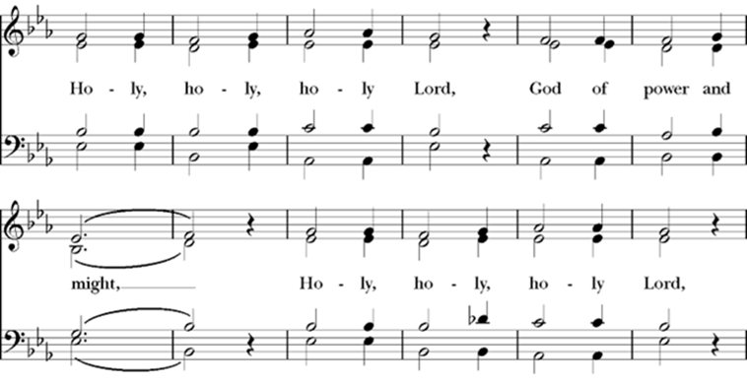
SANCTUS H82 S 130

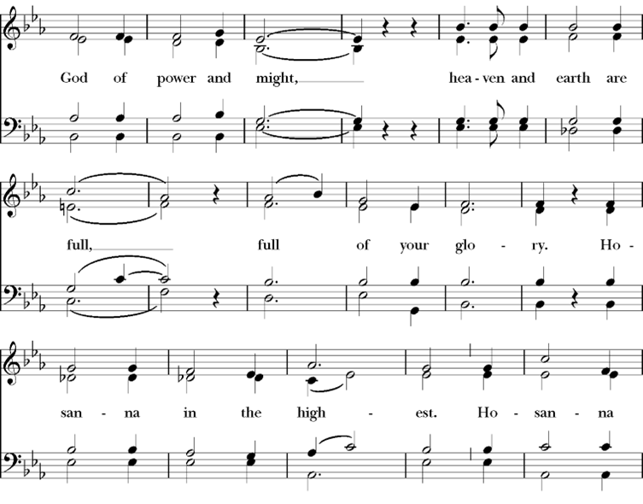

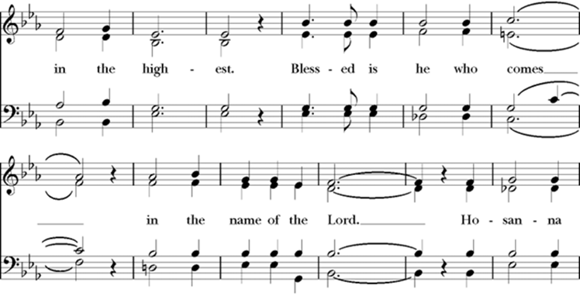

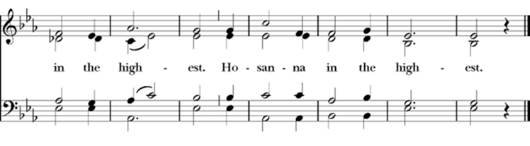

The people kneeling as able. When the Priest, standing before the Holy Table, hath so ordered the Bread and Wine, that he may with the more readiness and decency break the Bread before the People, and take the Cup into his hands, he shall say the Prayer of Consecration, as followeth
All glory be to thee, Almighty God, our heavenly Father, for that thou, of thy tender mercy, didst give thine only Son Jesus Christ to suffer death upon the Cross for our redemption; who made there (by his one oblation of himself once offered) a full, perfect, and sufficient sacrifice, oblation, and satisfaction, for the sins of the whole world; and did institute, and in his holy Gospel command us to continue, a perpetual memory of that his precious death and sacrifice, until his coming again:
For in the night in which he was betrayed, he took Bread; and when he had given thanks, he brake it, and gave it to his disciples, saying, Take, eat, this is my Body, which is given for you; Do this in remembrance of me.
Likewise, after supper, he took the Cup; and when he had given thanks, he gave it to them, saying, Drink ye all of this; for this is my Blood of the New Testament, which is shed for you, and for many, for the remission of sins; Do this, as oft as ye shall drink it, in remembrance of me.
THE OBLATION
Wherefore, O Lord and heavenly Father, according to the institution of thy dearly beloved Son our Saviour Jesus Christ, we, thy humble servants, do celebrate and make here before thy Divine Majesty, with these thy holy gifts, which we now offer unto thee, the memorial thy Son hath commanded us to make; having in remembrance his blessed passion and precious death, his mighty resurrection and glorious ascension; rendering unto thee most hearty thanks for the innumerable benefits procured unto us by the same.
THE INVOCATION
And we most humbly beseech thee, O merciful Father, to hear us; and, of thy almighty goodness, vouchsafe to bless and sanctify, with thy Word and Holy Spirit, these thy gifts and creatures of bread and wine; that we, receiving them according to thy Son our Saviour Jesus Christ's holy institution, in remembrance of his death and passion, may be partakers of his most blessed Body and Blood.
And we earnestly desire thy fatherly goodness, mercifully to accept this our sacrifice of praise and thanksgiving; most humbly beseeching thee to grant that, by the merits and death of thy Son Jesus Christ, and through faith in his blood, we, and all thy whole Church, may obtain remission of our sins, and all other benefits of his passion. And here we offer and present unto thee, O Lord, our selves, our souls and bodies, to be a reasonable, holy, and living sacrifice unto thee; humbly beseeching thee, that we, and all others who shall be partakers of this Holy Communion, may worthily receive the most precious Body and Blood of thy Son Jesus Christ, be filled with thy grace and heavenly benediction, and made one body with him, that he may dwell in us, and we in him. And although we are unworthy, through our manifold sins, to offer unto thee any sacrifice; yet we beseech thee to accept this our bounden duty and service; not weighing our merits, but pardoning our offences, through Jesus Christ our Lord; by whom, and with whom, in the unity of the Holy Ghost, all honour and glory be unto thee, O Father Almighty, world without end.
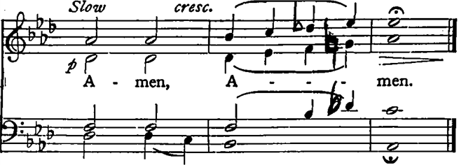

And now, as our Saviour Christ hath taught us, we are bold to say,
THE LORD’S PRAYER
Priest and people
Our Father, who art in heaven, Hallowed be thy Name. Thy kingdom come. Thy will be done, On earth as it is in heaven. Give us this day our daily bread. And forgive us our trespasses, As we forgive those who trespass against us. And lead us not into temptation, But deliver us from evil. For thine is the kingdom, and the power, and the glory, for ever and ever. Amen.
Then shall the Priest, kneeling down at the Lord's Table, say [with the people], in the name of all those who shall receive the Communion, this Prayer following
PRAYER OF HUMBLE ACCESS
Priest and people
We do not presume to come to this thy Table, O merciful Lord, trusting in our own righteousness, but in thy manifold and great mercies. We are not worthy so much as to gather up the crumbs under thy Table. But thou art the same Lord, whose property is always to have mercy: Grant us therefore, gracious Lord, so to eat the flesh of thy dear Son Jesus Christ, and to drink his blood, that our sinful bodies may be made clean by his body, and our souls washed through his most precious blood, and that we may evermore dwell in him, and he in us. Amen.
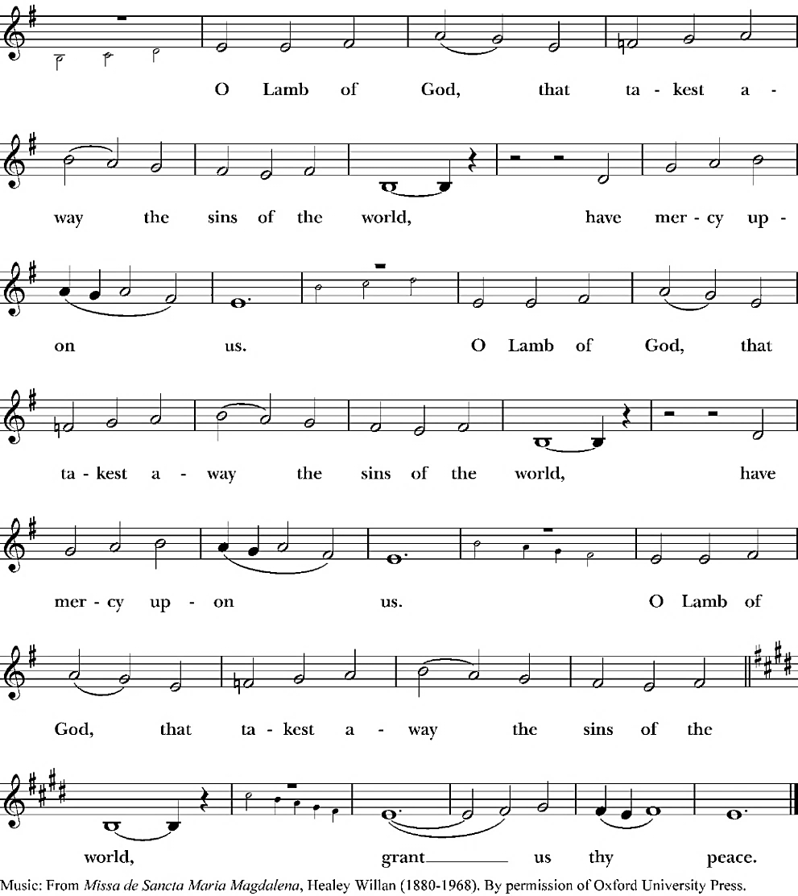
AGNUS DEI H82 S 158

COMMUNION
The priest turns to the people and says
The gifts of God for the people of God.
Then shall the Priest First receive the Holy Communion in both kinds himself, and proceed to deliver the same to the Bishops, Priests, and Deacons, in like manner, (if any be present,) and, after that, to the People also in order, into their hands, all devoutly kneeling as able at the altar rail.
Then shall the Priest say, the people kneeling as able,
POST-COMMUNION PRAYER
Let us pray.
Almighty and everliving God, we most heartily thank thee, for that thou dost vouchsafe to feed us who have duly received these holy mysteries, with the spiritual food of the most precious Body and Blood of thy Son our Saviour Jesus Christ; and dost assure us thereby of thy favour and goodness towards us; and that we are very members incorporate in the mystical body of thy Son, which is the blessed company of all faithful people; and are also heirs through hope of thy everlasting kingdom, by the merits of his most precious death and passion. And we humbly beseech thee, O heavenly Father, so to assist us with thy grace, that we may continue in that holy fellowship, and do all such good works as thou hast prepared for us to walk in; through Jesus Christ our Lord, to whom, with thee and the Holy Ghost, be all honour and glory, world without end. Amen.
Then shall be sung or said the Gloria in excelsis, all standing as able
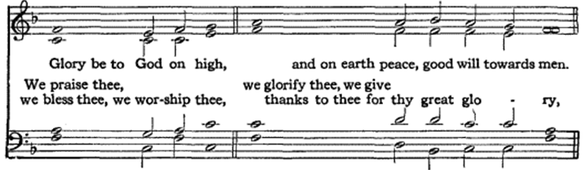
HYMN 739 Gloria in excelsis

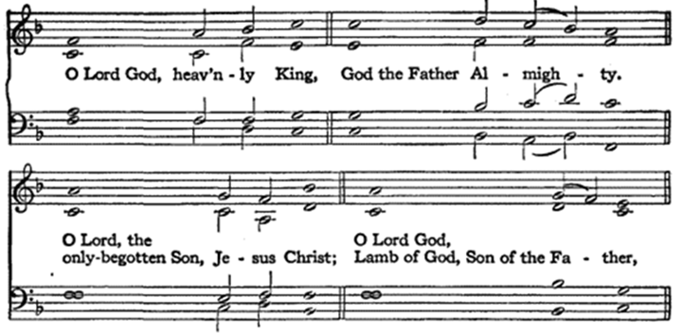

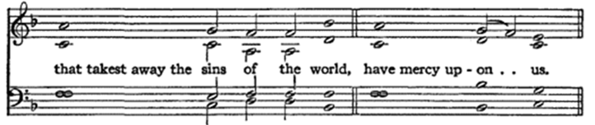

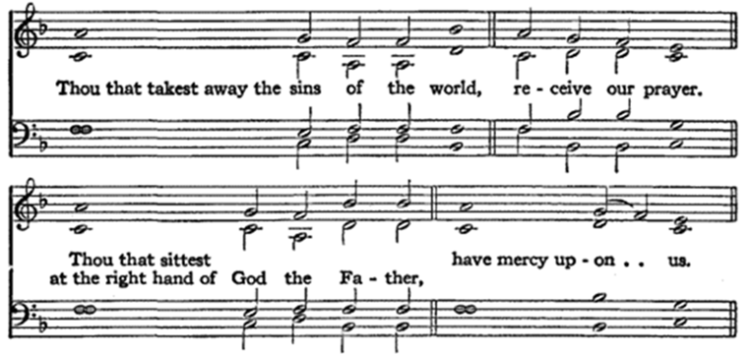

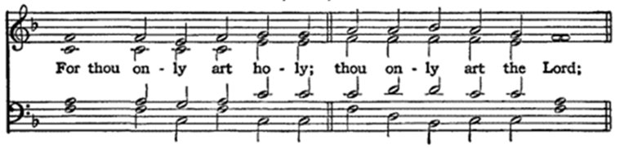

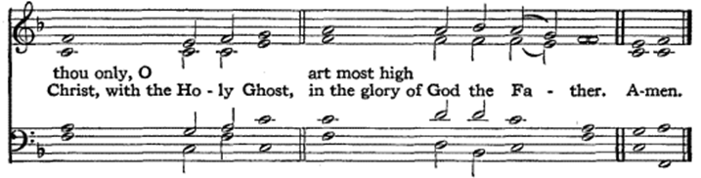

THE BLESSING
Then, the People kneeling, the Priest (the Bishop if present) shall let them depart with this Blessing
The Peace of God, which passeth all understanding, keep your hearts and minds in the knowledge and love of God, and of his Son Jesus Christ our Lord: And the Blessing of God Almighty, the Father, the Son, and the Holy Ghost, be amongst you, and remain with you always. Amen.
Standing as able
HYMN Be thou my vision H82 488
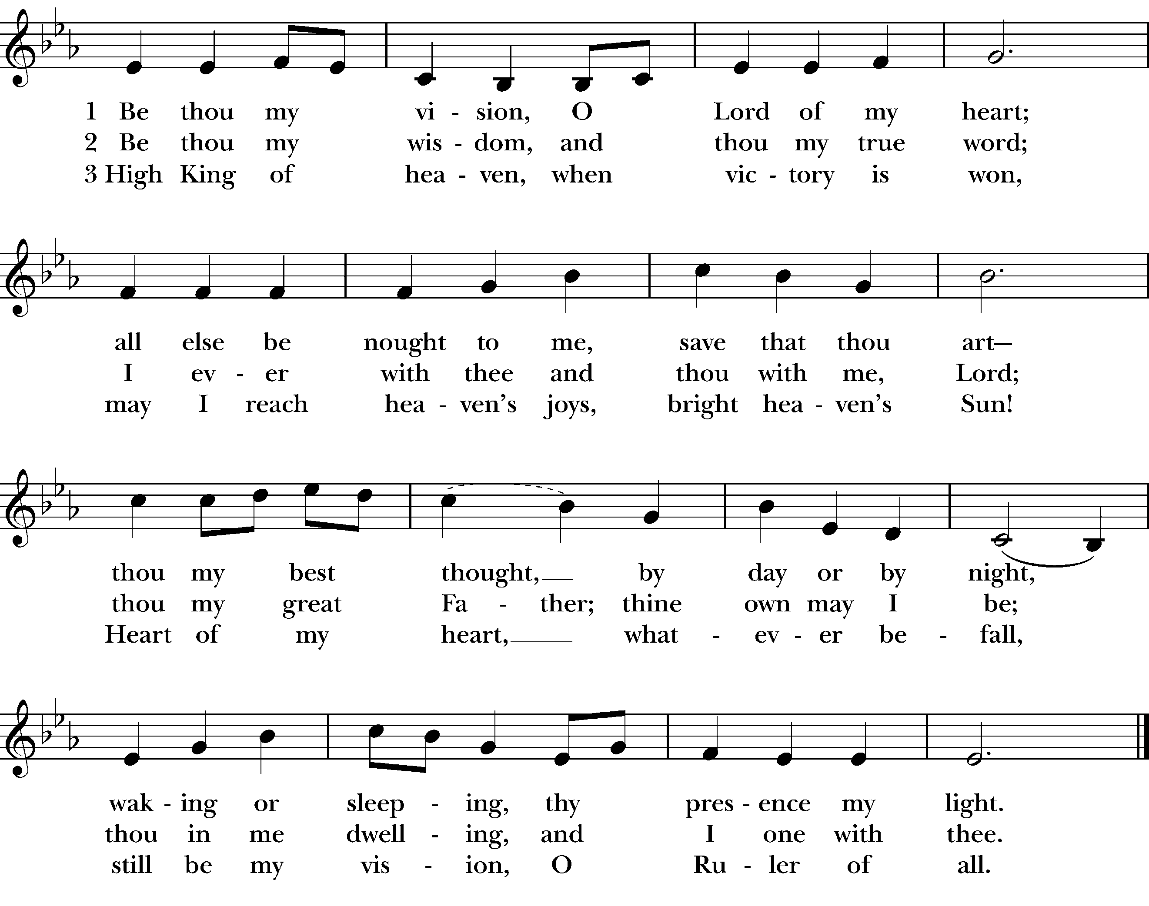

DISMISSAL
Priest Let us bless the Lord.
People Thanks be to God.
POSTLUDE
+ + + + +
ANNOUNCEMENTS
Serving Today
Acolyte: Art Brost
Lay Reader: D’aun Miles
Usher: Chibby Ogbuka
Vestry meets at 11:30 AM in Centennial Hall.
Finance Committee meets after Vestry.

Upcoming
- Shrove Tuesday, February 17, Pancake Supper, 4:30-6:30 PM, Parish Hall. Donation: $5/person, children eat for free
- Ash Wednesday, February 18, Imposition of Ashes & Holy Communion at 1 PM
- Sunday, February 22, Morning Prayer at 10 AM
Pastoral Emergency? Please call the church office (831) 375-4463, or to get in touch with Fr. Rick call (336) 613-2829.
Staff
Priest-in-Charge: The Very Rev. Dr. Richard Miles
Organist: Mary Clare Martin
Parish Administrator: Cynthia Brown
Bookkeeper: Brieanne Goldberg
Sexton: Jose Martinez
Vestry & Officers of the Parish
Senior Warden: Elizabeth Barratt
Junior Warden: Art Brost
Treasurer: Monica Nathan
Clerk: Elizabeth Barratt
Margee Bennett
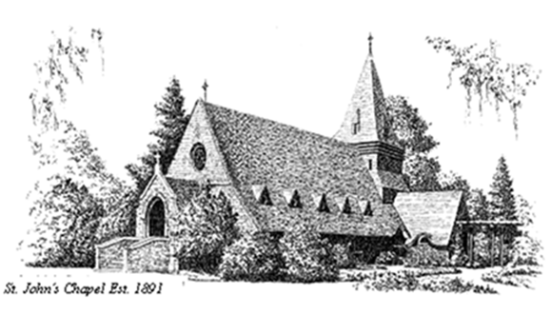
Jean Givetz
Chibby Ogbuka
Carl Patience

ST. JOHN’S CHAPEL
1490 Mark Thomas Drive, Monterey, CA 93940
Phone: 831-375-4463
Office Email: stjohnschapel@redshift.com
Website: stjohnschapel.com

