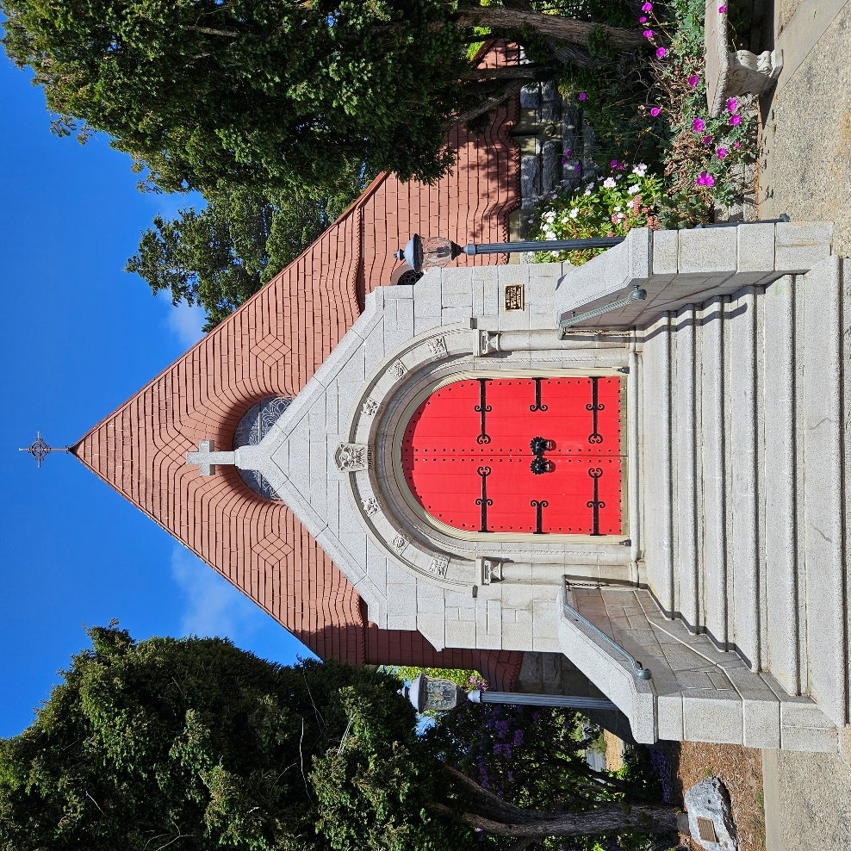

Eleventh Sunday after Trinity

Ordinary Time

1928 BCP Morning Prayer

Sunday, August 31, 2025 + 10 AM

St. John’s Chapel, Del Monte

**Welcome to St. John’s Chapel!**

*We are glad that you are worshipping with us this morning and pray that your experience here is a blessing to you. If you are a visitor, please fill out a Connection Card (pew rack) and place it in the offering plate or hand it to an usher. Let this bulletin be your guide through the service; it includes everything you need.*

***We are in Ordinary Time*** *and the liturgical color for this part of the year is green. Green really fits this season because it is all about growth in the Spirit and being nurtured. It is the kind of growth and nurturing that creates abundant fruit. In fact, in St. Paul’s Letter to the Galatians, Paul tells us that if we welcome the presence of the Holy Spirit within us, then the Spirit will produce fruit in us. “The fruit of the Spirit,” he says, “is love, joy, peace, patience, kindness, generosity, faithfulness, gentleness, and self-control” (Gal. 5:22–23). Through baptism, these virtues, these gifts of the Spirit, are planted in our soul. It is during this season of Ordinary Time that we work on cultivating the gifts of the Spirit.*

***Please stay for coffee in the Parish Hall after the service.***

*Throughout the service the People read the words in* ***bold italics*.**

**PRELUDE**

*All stand as able*

**HYMN 517 *Thine arm, O Lord, in days of old***

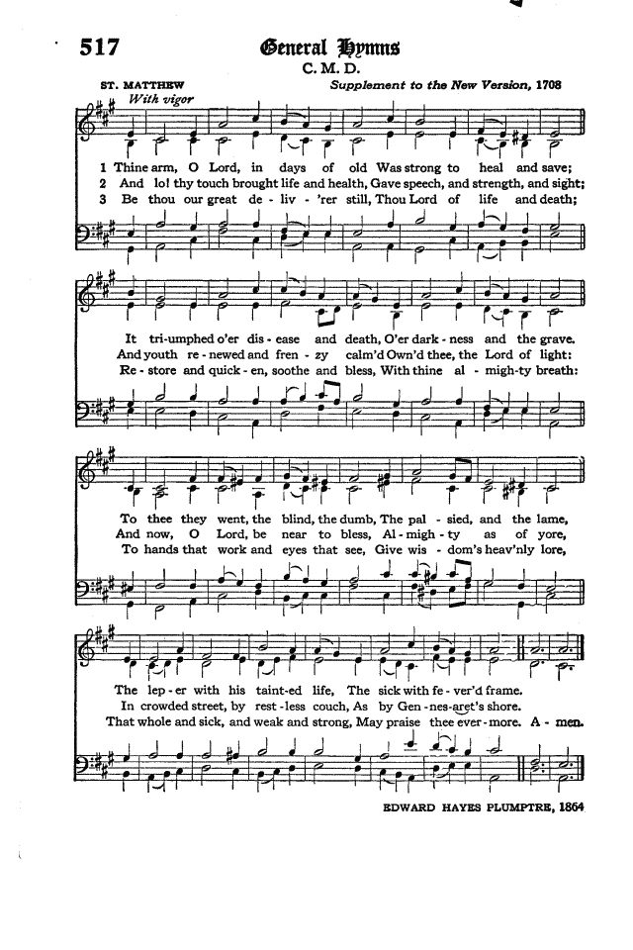

**OPENING SENTENCES**

*The people standing as able. The Officiant shall begin the Morning Prayer by reading the following*

The Lord is in his holy temple: let all the earth keep silence before him.

I was glad when they said unto me, we will go into the house of the Lord.

Let the words of my mouth, and the meditation of my heart, be always acceptable in thy sight, O Lord, my strength and my redeemer.

**SEASONAL SENTENCES: Trinity**

Holy, holy, holy, Lord God Almighty, which was, and is, and is to come. *Rev. 4:8*

*All kneeling as able, the Officiant says*

**THE DECALOGUE**

GOD spake these words, and said: I am the LORD thy God; Thou shalt have none other gods but me.

Thou shalt not make to thyself any graven image, nor the likeness of any thing that is in heaven above, or in the earth beneath, or in the water under the earth; thou shalt not bow down to them, nor worship them;

*People sing response*

Thou shalt not take the Name of the LORD thy God in vain;

*People sing response*

Remember that thou keep holy the Sabbath-day.

*People sing response*

Honour thy father and thy mother;

*People sing response*

Thou shalt do no murder.  
*People sing response*

Thou shalt not commit adultery.  
*People sing response*

Thou shalt not steal.  
*People sing response*

Thou shalt not bear false witness against thy neighbour.  
*People sing response*

Thou shalt not covet.

Hear what our Lord Jesus Christ saith.

Thou shalt love the Lord thy God with all thy heart, and with all thy soul, and with all thy mind. This is the first and great commandment. And the second is like unto it; Thou shalt love thy neighbour as thyself. On these two commandments hang all the Law and the Prophets.

**KYRIE**

*Then the Officiant says*

O Almighty Lord, and everlasting God, vouchsafe, we beseech thee, to direct, sanctify, and govern, both our hearts and bodies, in the ways of thy laws, and in the works of thy commandments; that, through thy most mighty protection, both here and ever, we may be preserved in body and soul; through our Lord and Saviour Jesus Christ. ***Amen.***

**GENERAL CONFESSION**

*Then the Officiant shall say*

Let us humbly confess our sins unto Almighty God.

*To be said by the whole congregation, all kneeling*

***Almighty and most merciful Father; We have erred, and strayed from thy ways like lost sheep. We have followed too much the devices and desires of our own hearts. We have offended against thy holy laws. We have left undone those things which we ought to have done; And we have done those things which we ought not to have done; And there is no health in us. But thou, O Lord, have mercy upon us, miserable offenders. Spare thou those, O God, who confess their faults. Restore thou those who are penitent; According to thy promises declared unto mankind In Christ Jesus our Lord. And grant, O most merciful Father, for his sake; That we may hereafter live a godly, righteous, and sober life, To the glory of thy holy Name. Amen.***

**ABSOLUTION**

*People kneeling as able, the Officiant says*

The Almighty and merciful Lord grant us absolution and remission of all our sins, true repentance, amendment of life, and the grace and consolation of his Holy Spirit. ***Amen.***

*All standing as able*

Officiant O Lord open thou our lips.

***People And our mouths shall show forth thy praise.***

Officiant Glory be to the Father, and to the Son, and to the Holy Ghost.

***People As it was in the beginning, is now, and ever shall be, world without end. Amen.***

Officiant Praise ye the Lord.

***People The Lord’s name be praised.***

**VENITE, EXULTEMUS DOMINO**

*Standing, sung or said by all together*

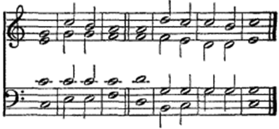

*Standing as able. Then shall follow a Portion of the Psalms. And at the end of the Psalm, shall be sung or said the Gloria Patri.*

**PSALM 125 *Qui confidunt***

*Reader:* We will read Psalm 125 responsively by the whole verse.

1 They that put their trust in the LORD shall be even as the mount Sion, * which may not be removed, but standeth fast for ever.  
***2 The hills stand about Jerusalem; * even so standeth the LORD round about his people, from this time forth for evermore.***3 For the sceptre of the ungodly shall not abide upon the lot of the righteous; * lest the righteous put their hand unto wickedness.  
***4 Do well, O LORD, * unto those that are good and true of heart.***5 As for such as turn back unto their own wickedness, * the LORD shall lead them forth with the evil doers; but peace shall be upon Israel***.***

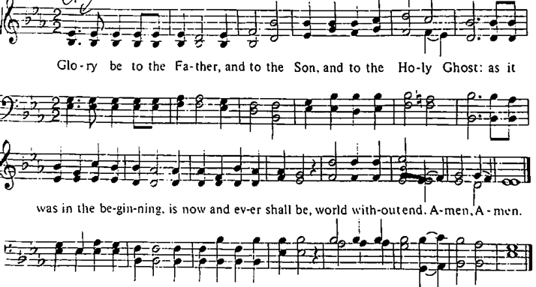

*The people sit*

**FIRST LESSON: Isaiah 26:12-16, 19**

*Reader:* A reading from the 26th chapter of the Book of Isaiah, beginning at the 12th verse.

Lord, thou wilt ordain peace for us: for thou also hast wrought all our works in us.  
O Lord our God, other lords beside thee have had dominion over us: but by thee only will we make mention of thy name.  
They are dead, they shall not live; they are deceased, they shall not rise: therefore hast thou visited and destroyed them, and made all their memory to perish.  
Thou hast increased the nation, O Lord, thou hast increased the nation: thou art glorified: thou hadst removed it far unto all the ends of the earth.  
Lord, in trouble have they visited thee, they poured out a prayer when thy chastening was upon them.  
Thy dead men shall live, together with my dead body shall they arise. Awake and sing, ye that dwell in dust: for thy dew is as the dew of herbs, and the earth shall cast out the dead.

*Reader:* Here endeth the First Lesson.

*Standing as able, sung or said by all together*

**BENEDICTUS ES, DOMINE**

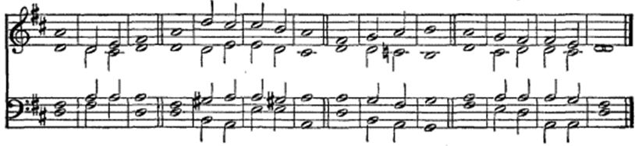

**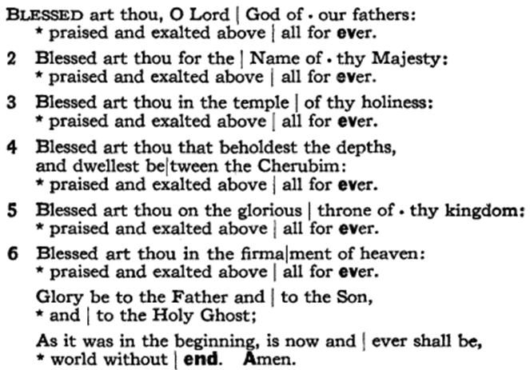***The people sit*

**SECOND LESSON: Romans 8:26-39**

*Reader:* A reading from the 8th chapter of Romans, beginning at the 26th verse.

Likewise the Spirit also helpeth our infirmities: for we know not what we should pray for as we ought: but the Spirit itself maketh intercession for us with groanings which cannot be uttered.  
And he that searcheth the hearts knoweth what is the mind of the Spirit, because he maketh intercession for the saints according to the will of God.  
And we know that all things work together for good to them that love God, to them who are the called according to his purpose.  
For whom he did foreknow, he also did predestinate to be conformed to the image of his Son, that he might be the firstborn among many brethren.  
Moreover whom he did predestinate, them he also called: and whom he called, them he also justified: and whom he justified, them he also glorified.  
What shall we then say to these things? If God be for us, who can be against us?  
He that spared not his own Son, but delivered him up for us all, how shall he not with him also freely give us all things?  
Who shall lay any thing to the charge of God’s elect? It is God that justifieth.  
Who is he that condemneth? It is Christ that died, yea rather, that is risen again, who is even at the right hand of God, who also maketh intercession for us.  
Who shall separate us from the love of Christ? shall tribulation, or distress, or persecution, or famine, or nakedness, or peril, or sword?  
As it is written, For thy sake we are killed all the day long; we are accounted as sheep for the slaughter.  
Nay, in all these things we are more than conquerors through him that loved us.  
For I am persuaded, that neither death, nor life, nor angels, nor principalities, nor powers, nor things present, nor things to come,  
Nor height, nor depth, nor any other creature, shall be able to separate us from the love of God, which is in Christ Jesus our Lord.

*Reader:* Here endeth the Second Lesson.

*Standing as able, sung or said by all together*

**JUBILATE DEO**

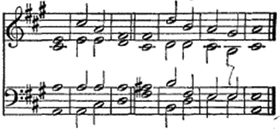

*The people sit*

**THE GOSPEL LESSON: Matthew 23:13-31**

*Reader*  A reading from the 23rd chapter of Matthew, beginning at the 13th verse.

But woe unto you, scribes and Pharisees, hypocrites! for ye shut up the kingdom of heaven against men: for ye neither go in yourselves, neither suffer ye them that are entering to go in.  
Woe unto you, scribes and Pharisees, hypocrites! for ye devour widows’ houses, and for a pretence make long prayer: therefore ye shall receive the greater damnation.  
Woe unto you, scribes and Pharisees, hypocrites! for ye compass sea and land to make one proselyte, and when he is made, ye make him twofold more the child of hell than yourselves.  
Woe unto you, ye blind guides, which say, Whosoever shall swear by the temple, it is nothing; but whosoever shall swear by the gold of the temple, he is a debtor!  
Ye fools and blind: for whether is greater, the gold, or the temple that sanctifieth the gold?  
And, Whosoever shall swear by the altar, it is nothing; but whosoever sweareth by the gift that is upon it, he is guilty.  
Ye fools and blind: for whether is greater, the gift, or the altar that sanctifieth the gift?  
Whoso therefore shall swear by the altar, sweareth by it, and by all things thereon.  
And whoso shall swear by the temple, sweareth by it, and by him that dwelleth therein.  
And he that shall swear by heaven, sweareth by the throne of God, and by him that sitteth thereon.  
Woe unto you, scribes and Pharisees, hypocrites! for ye pay tithe of mint and anise and cummin, and have omitted the weightier matters of the law, judgment, mercy, and faith: these ought ye to have done, and not to leave the other undone.  
Ye blind guides, which strain at a gnat, and swallow a camel.  
Woe unto you, scribes and Pharisees, hypocrites! for ye make clean the outside of the cup and of the platter, but within they are full of extortion and excess.  
Thou blind Pharisee, cleanse first that which is within the cup and platter, that the outside of them may be clean also.  
Woe unto you, scribes and Pharisees, hypocrites! for ye are like unto whited sepulchres, which indeed appear beautiful outward, but are within full of dead men’s bones, and of all uncleanness.  
Even so ye also outwardly appear righteous unto men, but within ye are full of hypocrisy and iniquity.  
Woe unto you, scribes and Pharisees, hypocrites! because ye build the tombs of the prophets, and garnish the sepulchres of the righteous,  
And say, If we had been in the days of our fathers, we would not have been partakers with them in the blood of the prophets.  
Wherefore ye be witnesses unto yourselves, that ye are the children of them which killed the prophets.

*Reader*  Here endeth the Gospel Lesson.

*All standing as able*

***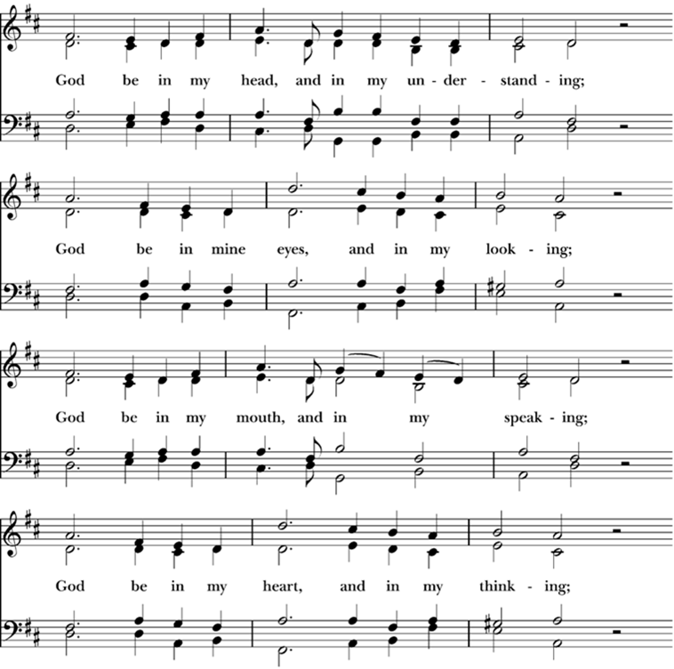*HYMN 694 *God be in my head Hymnal 1982***

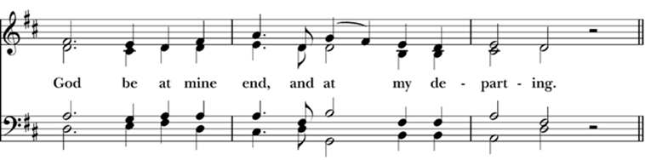

*The people sit*

**SERMON**

*All stand* *as able and say together*

**APOSTLES’ CREED**

***I believe in God the Father Almighty, Maker of heaven and earth: And in Jesus Christ his only Son our Lord: Who was conceived by the Holy Ghost, Born of the Virgin Mary: Suffered under Pontius Pilate, Was crucified, dead, and buried: He descended into hell; The third day he rose again from the dead: He ascended into heaven, And sitteth on the right hand of God the Father Almighty: From thence he shall come to judge the quick and the dead. I believe in the Holy Ghost: The holy Catholic Church; The Communion of Saints: The Forgiveness of sins: The Resurrection of the body: And the Life everlasting. Amen.***

**ANNOUNCEMENTS** *Please be seated*

**BIRTHDAYS & ANNIVERSARIES**

Birthday Prayer

***Watch over your child/children, O Lord, as their days increase; bless and guide them wherever they may be. Strengthen them when they stand; comfort them when discouraged or sorrowful; raise them up if they fall; and in their heart may your peace which passes all understanding abide all the days of their life; through Jesus Christ our Lord. Amen.***

Anniversary Prayer

***God of peace, your love is generous and reaches out to hold us all in your embrace. We pray now for the couple(s) before us, committed to each other in love. Fill their hearts with tenderness. Stay with them as they travel through good times, through trouble, or through change. Bless their home, their partings, and their meetings. Make them worthy of each other’s best and tender with each other’s dreams. May they always trust in your love. Amen.***

Prayer for Safe Travel

***Living God, the creator of all there is and whose presence we find wherever we go: preserve those who travel; surround them with your loving care; guard them from all that may harm them: and bring them in safety and joy to their journey’s end. Amen.***

**OFFERTORY**

*Officiant* Remember the words of our Lord Jesus Christ who said it is more blessed to give than to receive.

**HYMN 480 (v. 1 & 2) *Holy off’rings, rich and rare***

*Sung while seated*

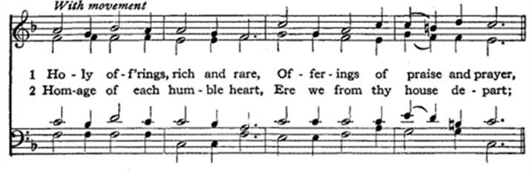

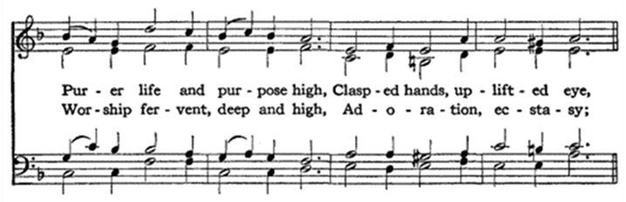

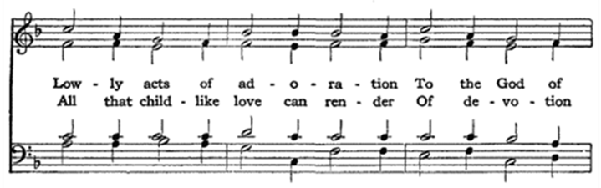

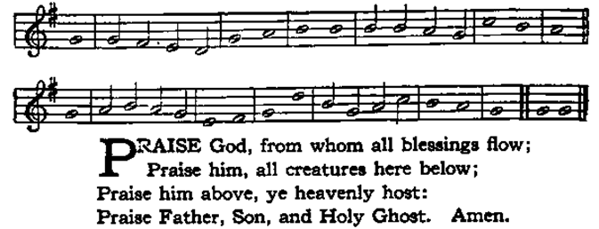**DOXOLOGY HYMN 139** *Standing as able*

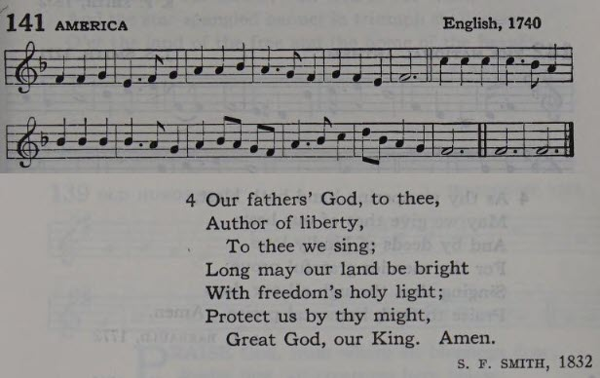**AMERICA HYMN 141, v. 4**

**OFFERTORY PRAYER**

*All standing as able, the Officiant takes the alms basin, stands in front of the altar, lifting the alms basin says*

*Officiant* All things come of thee, O Lord, and of thine own have we given thee.

*After which the people kneeling, the Officiant says*

Officiant The Lord be with you.

Answer ***And with thy spirit.***

Officiant Let us pray.

*All kneeling as able, all pray together*

**THE LORD’S PRAYER**

***Our Father, who art in heaven, Hallowed be thy Name. Thy kingdom come. Thy will be done, On earth as it is in heaven. Give us this day our daily bread. And forgive us our trespasses, As we forgive those who trespass against us. And lead us not into temptation, But deliver us from evil. For thine is the kingdom, and the power, and the glory, for ever and ever. Amen.***

**SUFFRAGES**

Officiant O Lord show thy mercy upon us.

***Answer And grant us thy salvation.***

Officiant O God, make clean our hearts within us.

***Answer And take not thy Holy Spirit from us.***

**COLLECTS AND PRAYERS**

***Collect for the Day***

O GOD, who declarest thy almighty power chiefly in showing mercy and pity; Mercifully grant unto us such a measure of thy grace, that we, running the way of thy commandments, may obtain thy gracious promises, and be made partakers of thy heavenly treasure; through Jesus Christ our Lord. ***Amen.***

***A Collect for Peace***

O God, who art the author of peace and lover of concord, in knowledge of whom standeth our eternal life, whose service is perfect freedom; Defend us thy humble servants in all assaults of our enemies; that we, surely trusting in thy defence, may not fear the power of any adversaries, through the might of Jesus Christ our Lord. ***Amen.***

***A Collect for Grace***

O Lord, our heavenly Father, Almighty and everlasting God, who hast safely brought us to the beginning of this day; Defend us in the same with thy mighty power; and grant that this day we fall into no sin, neither run into any kind of danger; but that all our doings, being ordered by thy governance, may be righteous in thy sight; through Jesus Christ our Lord. ***Amen.***

***A Prayer for The President of the United States,***

***and all in Civil Authority***

O Lord, our heavenly Father, the high and mighty Ruler of the universe, who dost from thy throne behold all the dwellers upon earth; Most heartily we beseech thee, with thy favour to behold and bless thy servant The President of the United States, and all others in authority; and so replenish them with the grace of thy Holy Spirit, that they may always incline to thy will, and walk in thy way. Endue them plenteously with heavenly gifts; grant them in health and prosperity long to live; and finally, after this life, to attain everlasting joy and felicity; through Jesus Christ our Lord. ***Amen.***

***A Prayer for the Clergy and People***

Almighty and everlasting God, from whom cometh every good and perfect gift; Send down upon our Bishops, and other Clergy, and upon the Congregations committed to their charge, the healthful Spirit of thy grace; and, that they may truly please thee, pour upon them the continual dew of thy blessing. Grant this, O Lord, for the honour of our Advocate and Mediator, Jesus Christ. ***Amen.***

***A Prayer for all Conditions of Men***

O God, the Creator and Preserver of all mankind, we humbly beseech thee for all sorts and conditions of men; that thou wouldest be pleased to make thy ways known unto them, thy saving health unto all nations. More especially we pray for thy holy Church universal; that it may be so guided and governed by thy good Spirit, that all who profess and call themselves Christians may be led into 18Morning Prayer the way of truth, and hold the faith in unity of spirit, in the bond of peace, and in righteousness of life. Finally, we commend to thy fatherly goodness all those who, are any ways afflicted, or distressed, in mind, body, or estate;

*We pray especially for:* Brighten, Randy, John S., Luke, Mackenzie’s family and friends, Beverly, Gloria, Gail, Dan and Caitlin, Lila, Bill B., Geoffrey and Amy, Art and Debbie, Danny, Logan, Nancy, Mousy and family, Christine and family, Connie, Jeremey, Carl, Zane, Bethany and family, Pete T., Bill S., Joanne, Mara Stephanie, Fr. Vincent Raj, Rocco, Claudette, Christina, Rori and Shane, Art C., Dean and Monica, James, Ron, Eva, Jane B., Peter, and all those whom we name in our hearts.

*And for those in military service:* Houessou Jonas, The Brown family, Alex Murray, The Birkelbach family, Walid Abou Chaar, Fouad El Hayek, Elizabeth Keller, Christine Puglia, The Riley family, The Logan Behr family, The Bingham family, The Elliot family, The Hollingsworth family, Zack and Ebony LeMaster, The O’Donnell family, and The Schaeffer family.

That it may please thee to comfort and relieve them, according to their several necessities; giving them patience under their sufferings, and a happy issue out of all their afflictions. And this we beg for Jesus Christ’s sake. ***Amen.***

***A General Thankgiving***

*All pray together*

***ALMIGHTY God, Father of all mercies, we, thine un- worthy servants, do give thee most humble and hearty thanks for all thy goodness and loving-kindness to us, and to all men; We bless thee for our creation, preservation, and all the blessings of this life; but above all, for thine inestimable love in the redemption of the world by our Lord Jesus Christ; for the means of grace, and for the hope of glory. And, we beseech thee, give us that due sense of all thy mercies, that our hearts may be unfeignedly thankful; and that we show forth thy praise, not only with our lips, but in our lives, by giving up our selves to thy service, and by walking before thee in holiness and righteousness all our days; through Jesus Christ our Lord, to whom, with thee and the Holy Ghost, be all honour and glory, world without end. Amen.***

***A Prayer of St. Chrysostom***

*The Officiant says*

Almighty God, who hast given us grace at this time with one accord to make our common supplications unto thee; and dost promise that when two or three are gathered together in thy Name thou wilt grant their requests; Fulfil now, O Lord, the desires and petitions of thy servants, as may be most expedient for them; granting us in this world knowledge of thy truth, and in the world to come life everlasting. ***Amen.***

**HYMN 411 *O thou to whose all-searching sight***

**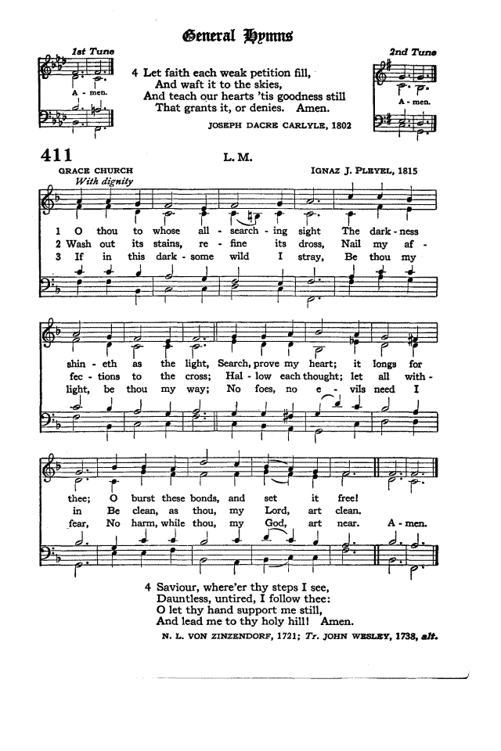***Standing as able*

**DISMISSAL**

*Officiant* Let us go forth into the world rejoicing in the power of the Spirit.

*People* ***Thanks be to God.***

**POSTLUDE**

**+ + + + +**

**ANNOUNCEMENTS**

**Serving Today**

**Officiant:** Carl Patience

**Acolyte:** *TBD*

**Lay Reader:** Jean Givetz

**Usher:** Chibby Ogbuka

**Pastoral Emergency?** Fr. Miles is on vacation through August 9th. Please call the church office (831) 375-4463 if you need pastoral care.

**Upcoming**

* **Sunday, September 7,** Holy Communion at 10 AM.
* **Sunday, September 14,** Holy Communion at 10 AM.
  + **Vestry,** at 11:30 AM, Centennial Hall.
  + **Finance Committee,** following Vestry.

*The bulletins are completely underwritten by a private donation.*

**Staff**

Priest-in-Charge: The Very Rev. Dr. Richard Miles

Organist: Mary Clare Martin

Parish Administrator: Cynthia Brown

Bookkeeper: Brieanne Goldberg

Sexton: Jose Martinez

**Vestry & Officers of the Parish**

Senior Warden: Geoffrey Holland

Junior Warden: Art Brost

Treasurer: Monica Nathan

Clerk: Elizabeth Barratt

Jean Givetz

Amy Holland

Chibby Ogbuka

Luke Stock Moran

**Ministry Directors**

Director of Readers: Monica Nathan

Director of Ushers: Chibby Ogbuka

Director of Acolytes: Art Brost

Altar Guild: Alice Bowhay, Jean Givetz, Gail Strandberg, Marti Myszak, and Margee Bennett

Weddings: Margee Bennett and Cynthia Brown

Historians/Archivists: Richard & Elizabeth Barratt

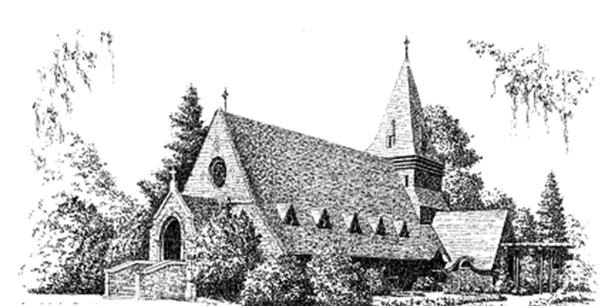

**ST. JOHN’S CHAPEL**

1490 Mark Thomas Drive, Monterey, CA 93940

Phone: 831-375-4463

Office Email: [stjohnschapel@redshift.com](mailto:stjohnschapel@redshift.com)

Website: stjohnschapel.com